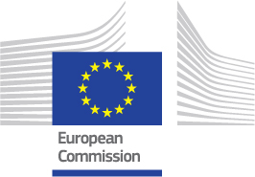
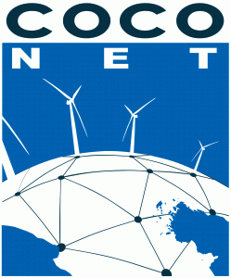

Registration Form
CoCoNet

Final Meeting

Lecce

DECEMBER 1st-2nd 2015

PARTNER NUMBER AND ACRONYM | PARTICIPANT NAME AND SURNAME | E-MAIL ADDRESS

Please return completed form
before September 30th 2015
to the following address:
palama@conisma.it

The agenda and suggestions for the hotels in the area will be circulated shortly.

